====Tutorial 04 05 Unity Animations with Standard Asset FPC, Visual Scripting Dialog
This will be the workflow for CW1.

Tutorial 03 – Unity Mia Animator and Parameters recap
https://www.youtube.com/watch?v=miEewb5lXwo

- Ensure all example Models and clips have same Humanoid Rig and Avatar from Mia or Mixamo TPose File
- Ensure Clips Stand Loop (Idle) and Stand Talk 1 a,b,c are rooted with no compression (either root or no root methods)
- Take Loop off Stand Talk 1a, b, c
- Drag Stand Loop into Animator Window – Right click and Set as Layer Default State
- This runs the idle animation off the Entry Node
- Drag the Clips Talk 1 a,b,c into the Animator Window
- Right Click on the ‘Any State Node’ and make transitions to each in turn
- Right Click on each of the 3 Talk clips and transition each to the Exit node.
- Click on Animator window Parameters Tab
- Create Three new Trigger Parameters and name Talk 1a, Talk 1b, Talk 1c
- Right Click on each of the transitions from Any State and add a condition of transition for each that uses the appropriately named Trigger
- Make sure ‘Has Exit Time’ is Unchecked here
- Make sure ‘Has Exit Time’ is Checked in the Transitions to the Exit Node.
- Use trigger script from week 03 to make interaction

Tutorial 04 01– Mia with Unity Standard Assets Package: Characters-First Person Controller Prefab
https://www.youtube.com/watch?v=H9yS5CHPCtY
https://www.youtube.com/watch?v=iCLnz5oUIpU
Starter Assets (Standard Lighting, needs some material adjustment back to standard) FPC
https://assetstore.unity.com/packages/essentials/starter-assets-firstperson-updates-in-new-charactercontroller-pa-196525
In Hierarchy with playground, select each object with pink material and select Standard for Shader
Overview of Unity Character Controllers: https://www.youtube.com/watch?v=e94KggaEAr4
- Import Starter Assets FPC - from tools panel or asset store link above
  - This will require you to login to Unity
  - It will also put the package in “My Assets” in package manager window
  - Open in Unity - Download - Import
  - This imports cinemachine
  - This imports new unity input system
  - Accept restart on window prompt
  - You will have to import FPC package again from website after restart
  - Starter assets should be in Assets folder now.
  - New Unity input system knocks out Unity UI for FPC, so both should be selected…
  - Edit/Project settings/Player settings /Input system/Active Input Handling - drop down menu - make sure both is selected
https://gyazo.com/8b2bb784d1b0fd4f5dcb062345354a6c

g. Your packages in Project window should look like this:
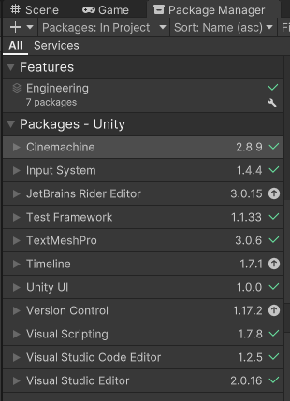

- Import FPC Sample Scene - Playground – Double click to load
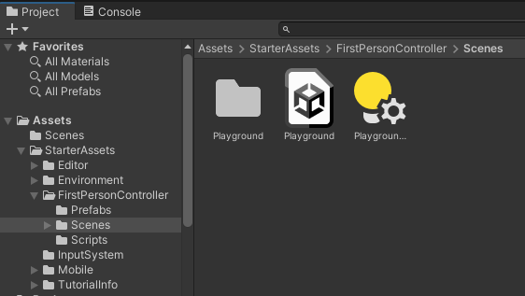
https://gyazo.com/1c0595dff29ea50531454bc520b90449
  - This has the joysticks needed for control
  - Tic to activate UI SA Inputs in Hierarchy (greyed out)
  - This needs some adjustment to work
  - If you drag in the scene to hierarchy in the video, you have 2 scenes in the hierarchy – and it may crash Unity though - You have to move Mia over to the Playground Scene and right-click remove the old scene, or start with the playground and add Mia with Animator Controller (unlike in the video!!!)
  - Playground scene should just be double clicked to load up, then you can drag in Mia/Animator after.
  - The Playground Scene will be Pink – This is a URP mismatch.
  - Change Scriptable Render Pipeline Settings from “None” to a Universal Render Pipeline (URP) setting (below) by clicking on the circle to the right of the box and selecting one of the URP options – “medium” is used here:
  - Drag Playground settings (next to playground scene in the starter assets) to a lighting panel (open with Window/Rendering.Lighting if needed)
  - Select All Materials in Project Window/Favorites at top
  - Select all pink materials
  - Edit/Rendering/Materials/Convert to URP
  - This will not work for some, so select these in the hierarchy window and set Shader to “Standard” to fix
  - Mia can be exported/imported as a package (on BB or from your week 03).
  - She will turn up Pink, - find the mia materials (Body and Face) in “All Materials” that are set to URP and drag them over the Mia Meshes to fix
  - You can also download and Import the MiaTut04StartURP.unitypackage
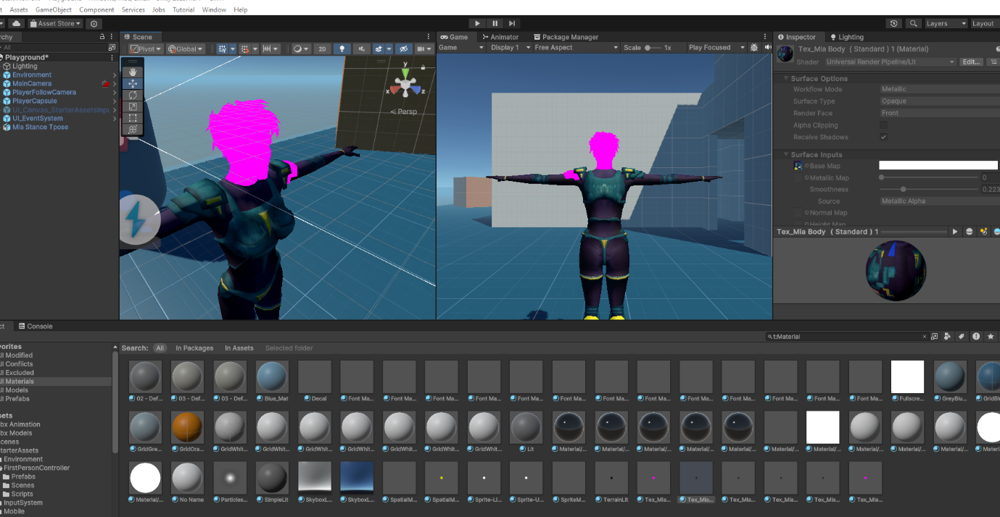

3. Activate “UI Canvas StarterAssetsInputs Joysticks” by ticking box in inspector
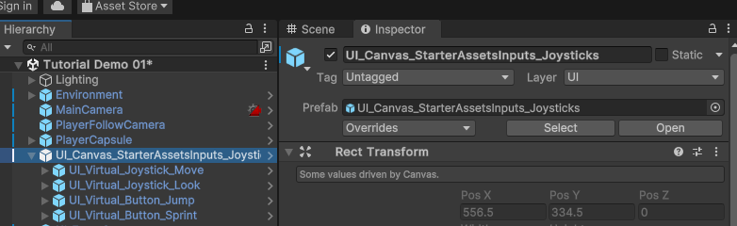
https://gyazo.com/ef43ac81bf9565a53a3aa46fe069aafc
  - Do The following to Use Unity UI interaction:
    - Player capsule - mouse cursor settings in Starter Assets Inputs:
      - Cursor locked - untick
      - Cursor input for look – untick
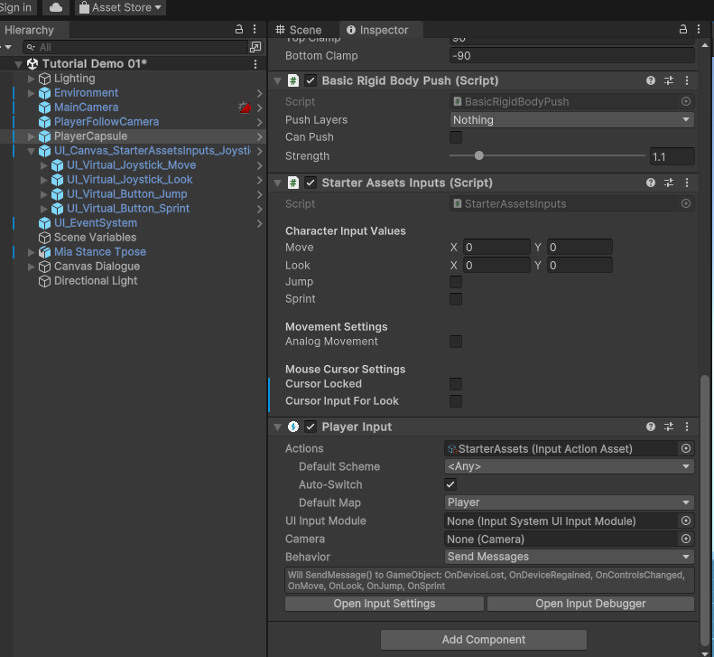
https://gyazo.com/ff0fb2548e8f2ea53775b4ed8c48a3f3
    - UI Event System (Unity Bug!) - change to "All pointers As Is” in Pointer Behaviour “mouse or pen” does not work
Note: Single Unified Pointer may work now (2022)
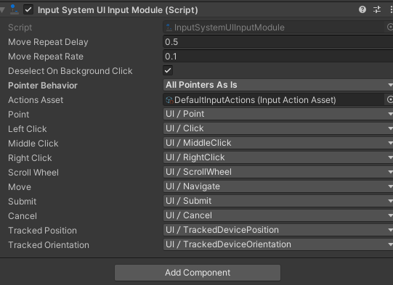

The UI_Virtual_Joystick_Look will be too powerful at 60 and 30. Change the settings to 1 and 0.5 in Inspector as below.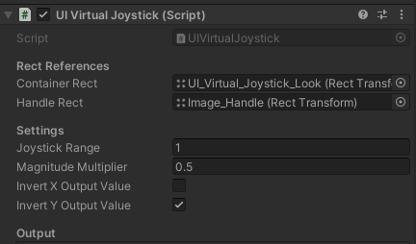
https://gyazo.com/feaecc836b2c9ff7a99fb41442bb9246

    - Can now use WASD, onscreen mouselook and joystick, and UI buttons
    - NOTE: if you are doing C# code - add the namespace to scripts:
using UnityEngine.UI;
4. Overview
  - Canvas sends out event
  - Parent canvas is listening with script
  - Sends out to player capsule/starter assets script
  - Event System needs input Options
  - Cameras need correct raycasters - Add Physics Raycaster to Main Camera and select mixed or everything in drop down:
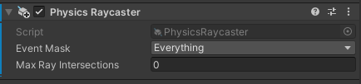

5. Basic Clicks on Scene Objects: Player Character
- Add Capsule Collider Component to Mia Stance TPose
  - Does not need to be trigger
- Add Component/Visual Scripting/ Script Machine to Mia Stance TPose
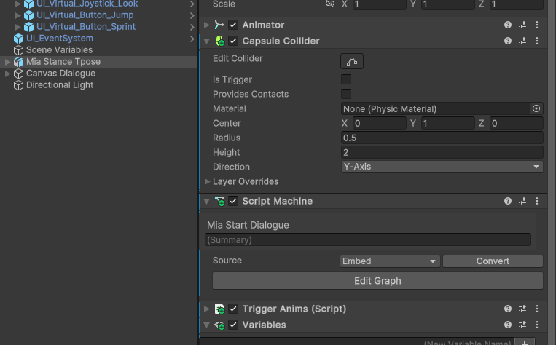
https://gyazo.com/fe39ea86fe78ea995250872e5194ccbc
  - In Source, select Embed in drop down
  - This allows use of scene objects
  - (Graph option only uses prefabs - which we look at later)
  - Be careful - switching will wipe code.
  - Name Script Mia Start Dialogue
  - Select Edit Graph Button - Script Window tab opens
  - Right click in Graph window and add:
      - On Pointer Down
      - Debug Log
      - String Literal
      - Wire as below:
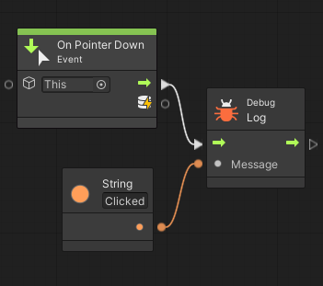
Tutorial 04 02 – Unity UI System and Visual Scripting for Dialogue
https://www.youtube.com/watch?v=iCLnz5oUIpU

- Canvas:
    - Create UI Canvas with right click in Hierarchy
    - Change name to Canvas Mia Dialogue
    - Change Render Mode in Inspector to World Space
    - Drag in Main Camera to Event Camera (handles click events)
    - Rect Transform
      - Zero out position
      - Make position -.6, 1.5 0 or next to Mia’s head
      - Make Width 600, Height 300
      - Make Scale .001 for X,Y,Z (1 Unit = 1 M!)
      - Rotate Y to 180
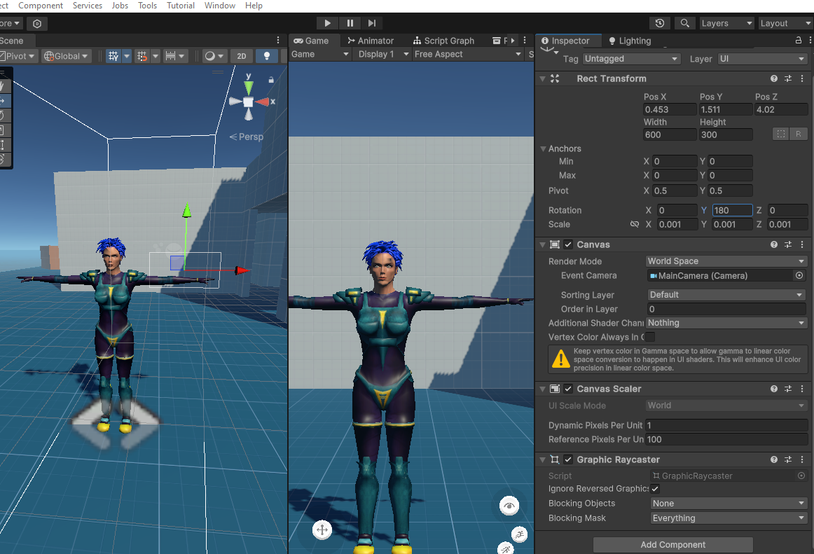
https://gyazo.com/84ca6a68a0b8c75c032fd6fa5b5ff8d5
2. Text:
    - Right click Canvas in Hierarchy and create UI/Text
(Legacy/Text or Text Mesh Pro. if text mesh Pro, accept all imports of essentials and examples)
    - Name Text As Dialogue Text 0
    - Change Width to 500 and Height to 60
    - Change Position to -15, 88, 0 or at top of canvas
    - Change font size to 28

3. Visual Script Graph:
    - Use previous Script Graph on the Mia character with the Debug function
    - Add “Text Set Text” node
    - Drag Dialog text into game object slot
    - Add new “String Literal” node
    - Type “Mia: Hello, can you take my order?” in the box.
    - Wire as below and play test:
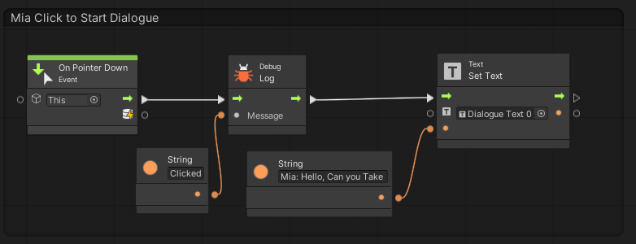
If you are using Text Mesh Pro, you need to use node “Text Mesh Pro UGUI: Set Text with Argument”:
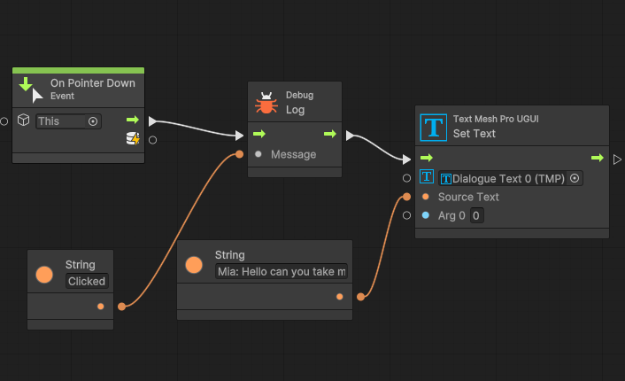
https://gyazo.com/bfe76bb5ea260a493c90d0a862bb3a71

4. Dialogue system - Dialogue Counter, Dialogue list, Button
- Create a Visual Script as before (Embed) on the Canvas Dialogue
- Create Scene Variable in the Graph Inspector tab on left
    - Dialogue List - Type: List of String
    - Anim Trigger List - Type: List of String
    - Dialogue Counter - Type: Integer
- Create a UI button on the dialogue canvas for forwarding
  - Position at end of Dialogue Text Box

04 02 a, b,c,d - Follow the below to create the CW1 Dialogue system:

Videos:
Overview 04 05:
Tutorial 04 02 d Crop.mp4
04 02 a
Tutorial 04 02 a Crop.mp4 14:24
04 02 b
Tutorial 04 02 b Crop.mp4 7:25 starts from crash and set text box
04 02 c
Tutorial 04 02 c Crop.mp4 17:17 - starts with visual script - does dialogue up to anim trigger
04 02 d
Tutorial 04 02 d Crop.mp4 9:33 - demos the dialogue

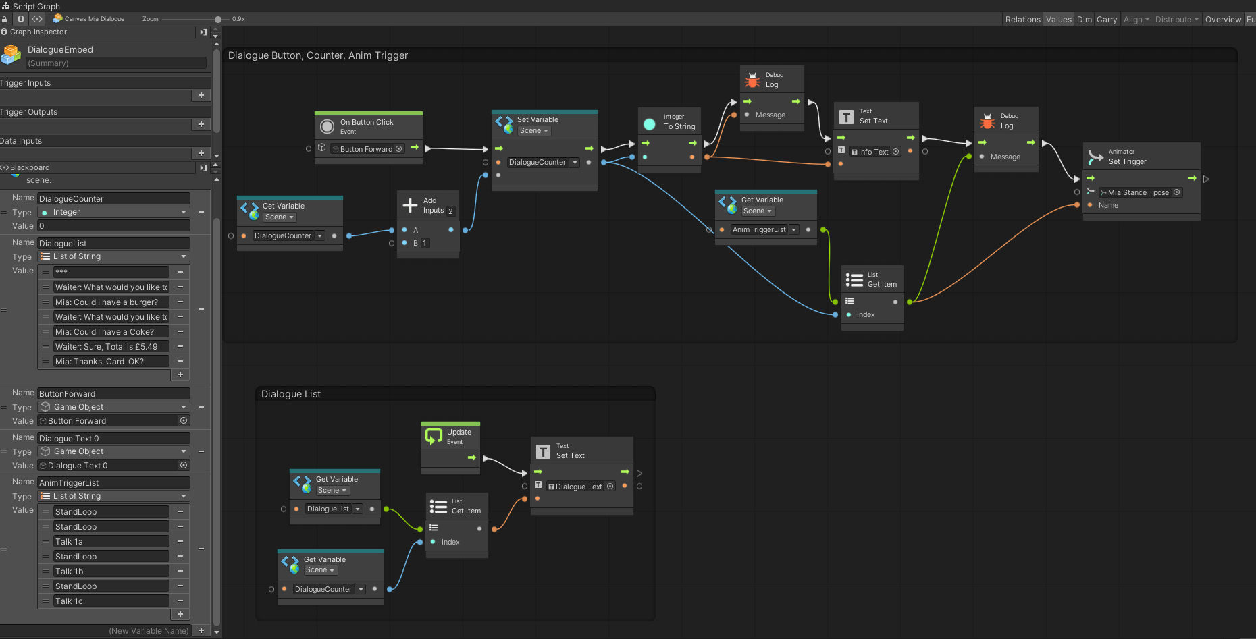
https://gyazo.com/2b34005e1ac917b6b6c0abc126692338

Rough tasks:
- Script Graph on Dialogue Canvas - Embed to access scene variables
- Create Scene Variables: Type “List of String” for Anim Triggers and Dialogue Text
- Create Scene Variable: Type Integer for Dialogue Counter
- Add nodes to set dialogue variable and increment with a button or key input
- Use dialogue counter to access Arrays to trigger animations and set Unity UI dialogue text
- Organise with Ctrl-LMB click drag to make housekeeping boxes

NOTE: Changing Scene Variables in the Script graph will probably require a refresh - drag the scene variables back into the script graph window to replace and refresh them!

Dialogue Fix for out of range Array:
Add if statement to check if dialogue counter is less than or equal to end of array

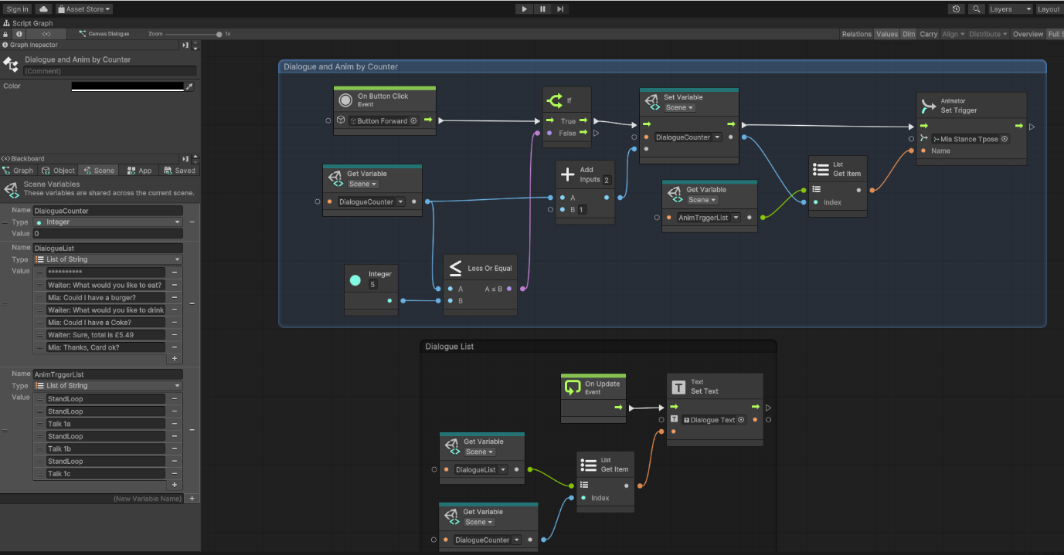
https://gyazo.com/09121b69fefd61992349e18598c67df6

